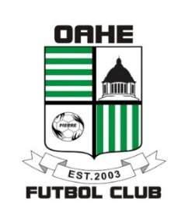

Oahe Futbol Club

Annual General Membership Meeting

Wednesday July 30th, 2025 – 7:00pm

Morris Inc. Building – Fort Pierre

1. Call to Order
2. Roll Call
3. Recognition of Guests/Members
4. Approval of Agenda
5. Approval of July 2024 Annual General Membership Meeting Minutes
6. Board of Directors/ Committee Reports
   1. Finance Committee - Dillman
   2. Coaching Committee\State Association – Sargent
   3. Rules & Regulations
   4. Fundraising
   5. President’s report – Larson
7. Members open forum
8. New Business
   1. Election of Directors
9. Miscellaneous
10. Next Meeting
11. Adjourn